ETHICAL HACKING

KALI LINUX BASIC COMMANDS

Date command-

The **'date'** command is used to display the **system date** and **time.**



Cd command-

The **'cd'** command is also called **chdir** (Change Directory). We used this command to **change** or **switch** the current working directory.

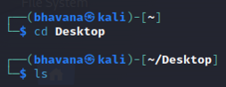

Cp command-

The **'cp'** command is used to **copy** files or a group of files or directories that create an exact image of a file

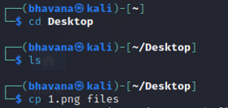

Whoami command-

The **'whoami'** command is used to print the effective **user ID** whereas the **who** command prints information regarding users who are presently logged in.

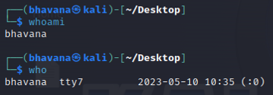

Ls command-

The **ls** command lists the directory contents of files and directories.

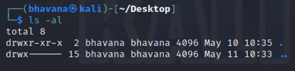

Cat command-

, we use the cat command to display the content of a file.

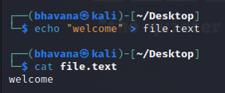

Mkdir command-

The **'mkdir'** command is used to **create directories.**

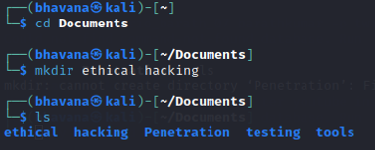

Rm command-

The **'rm'** command is used to **delete files.**

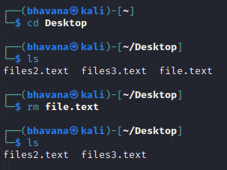

Mv command-

The **'mv'** command, we can **move** or **renames** files and directories on our file system.

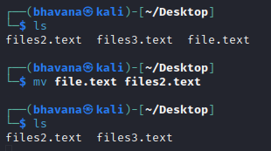

Uname command-

The **'uname'** command displays the **current system's information.**

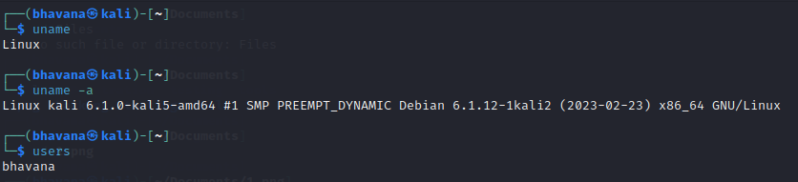

Uptime command-

The **'uptime'** command displays the amount of time the system has been running.

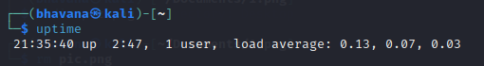

Users command-

The **'users'** command is used to display the **login names** of users logged in on the system.

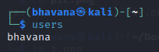

Less command-

The **'less'** command is used to view files instead of opening the file.

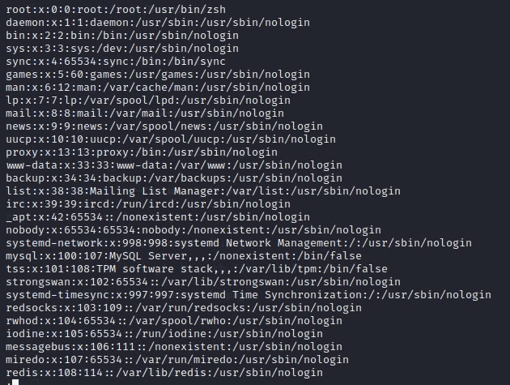

More command-

The **"more"** command permits us to show output in the terminal one page at a time.

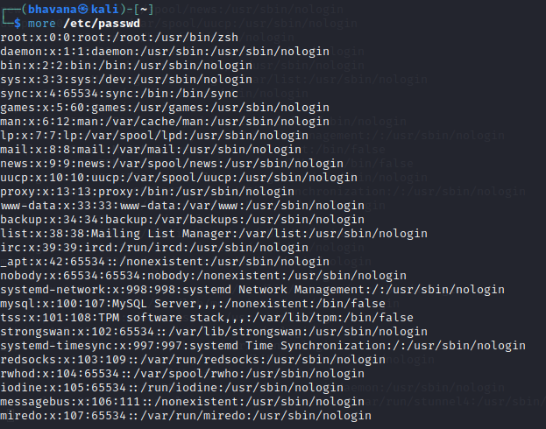

Vi command-

The **'vi'** editor is a screen editor that comes with practically every **UNIX** system. The **command mode** and the **insert mode** are the two most common nodes in vi.



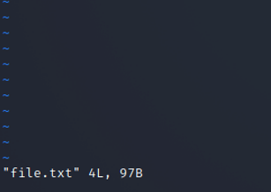

Free command-

The **'free'** command provides us the useful information about the **amount of RAM** available on a Linux machine

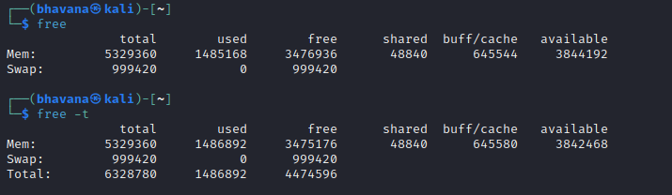

History command-

History command in the bash shell saves a history of commands entered that can be used to repeat commands.

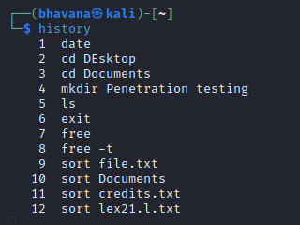

Pwd command-

The **'Pwd'** command is used to **print working directory.**

